实验七：组合模式
个人与组织：个人必定属于每一个组织，组织可以组合成更大的组织。

(1) 安全组合模式

1.1 UML图
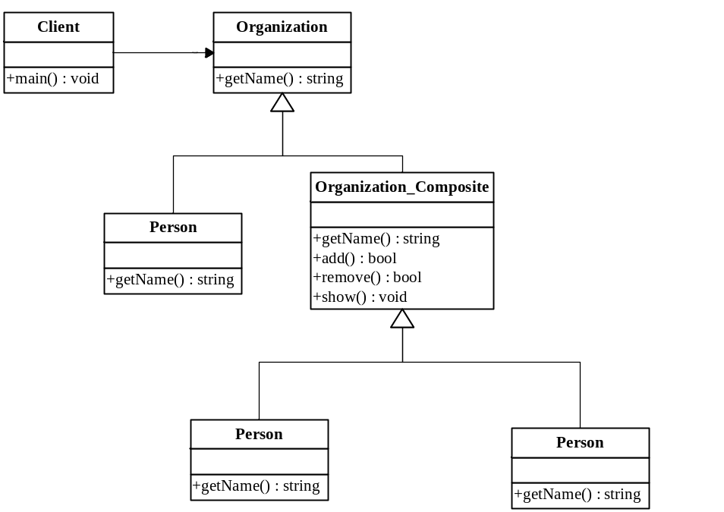

1.2 代码
package cn.edu.scau.cmi.liuweiming.composite.safe;

public abstract class Organization {
String name;
Organization(String _name) {
name = _name;
}
abstract String getName();
}

package cn.edu.scau.cmi.liuweiming.composite.safe;

public class Person extends Organization {

public Person(String _name) {
super(_name);
}

@Override
public String getName() {
return name;
}

}

package cn.edu.scau.cmi.liuweiming.composite.safe;

import java.util.ArrayList;

public class Organization_Composite extends Organization {
public Organization_Composite(String _name) {
super(_name);
}

ArrayList<Organization> ls = new ArrayList<Organization>();

public boolean add(Organization arg0) {
return ls.add(arg0);
}

public boolean remove(Organization arg0) {
return ls.remove(arg0);
}

public void show() {
for (int i = 0; i < ls.size(); ++i) {
System.out.println(ls.get(i).name);
}
}

@Override
public String getName() {
return name;
}
}

Client:
package cn.edu.scau.cmi.liuweiming.client;

import cn.edu.scau.cmi.liuweiming.composite.safe.Organization;
import cn.edu.scau.cmi.liuweiming.composite.safe.Organization_Composite;
import cn.edu.scau.cmi.liuweiming.composite.safe.Person;

public class Composite_Safe {
public static void main(String args[]) {
Organization person = new Person("vimi");
System.out.println("person name : " + ((Person)person).getName());

Organization o = new Organization_Composite("man group");
((Organization_Composite)o).add(new Organization_Composite("liangzaoqing"));
((Organization_Composite)o).add(new Organization_Composite("liuweiming"));
((Organization_Composite)o).add(new Organization_Composite("student"));
System.out.println("organization name : " + ((Organization_Composite)o).getName());
((Organization_Composite)o).show();
}
}

(2) 一致性组合模式

2.1 UML图

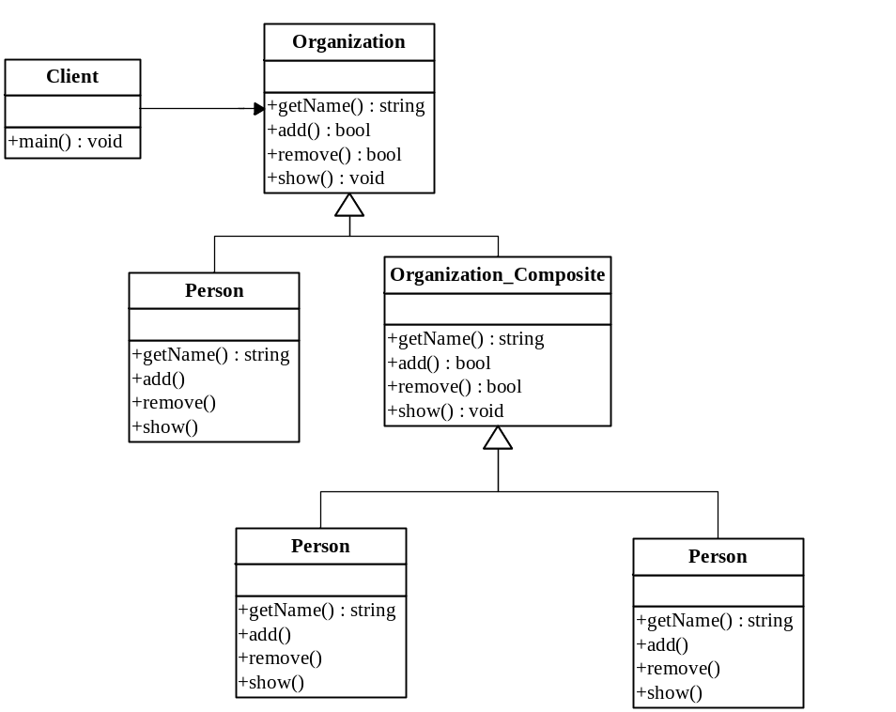

2.2 代码
package cn.edu.scau.cmi.liuweiming.composite.transparent;

import java.util.ArrayList;

public abstract class Organization {
ArrayList<Organization> ls = new ArrayList<Organization>();
String name;
Organization(String _name) {
name = _name;
}
public abstract String getName();
public abstract boolean add(Organization arg0);
public abstract boolean remove(Organization arg0);
public abstract void show();
}

package cn.edu.scau.cmi.liuweiming.composite.transparent;

public class Organization_Composite extends Organization {

public Organization_Composite(String _name) {
super(_name);
}

@Override
public String getName() {
return name;
}

@Override
public boolean add(Organization arg0) {
return ls.add(arg0);
}

@Override
public boolean remove(Organization arg0) {
return ls.remove(arg0);
}

@Override
public void show() {
for (int i = 0; i < ls.size(); ++i) {
System.out.println(ls.get(i).name);
}
}

}

package cn.edu.scau.cmi.liuweiming.composite.transparent;

public class Person extends Organization {
String errMessage = "can not use it";

public Person(String _name) {
super(_name);
}

@Override
public String getName() {
return name;
}

@Override
public boolean add(Organization arg0) {
System.err.println(errMessage);
return false;
}

@Override
public boolean remove(Organization arg0) {
System.err.println(errMessage);
return false;
}

@Override
public void show() {
System.err.println(errMessage);
}

}

Client:
package cn.edu.scau.cmi.liuweiming.client;

import cn.edu.scau.cmi.liuweiming.composite.transparent.Organization;
import cn.edu.scau.cmi.liuweiming.composite.transparent.Organization_Composite;
import cn.edu.scau.cmi.liuweiming.composite.transparent.Person;

public class Composite_transparent {
public static void main(String args[]) {
Organization person = new Person("vimi");
System.out.println("person name : " + person.getName());

Organization o = new Organization_Composite("man group");
o.add(new Organization_Composite("liangzaoqing"));
o.add(new Organization_Composite("liuweiming"));
o.add(new Organization_Composite("student"));
System.out.println("organization name : " + o.getName());
o.show();
}
}

实验效果
